**What is selenium :** It is open source functional automation tool.

Why selenium :

+open source

+ supports multiple languages : java c# php perl, python etc.

+ Supports multiple browsers. FF, IE, GC, etc.

+ Supports multiple OS. : win. Mac, linux etc.

+ Supports web applications.

Selenium IDE : Integrated Development Environment. Use to record and run the scripts.

Selenium RC : Remote Control :

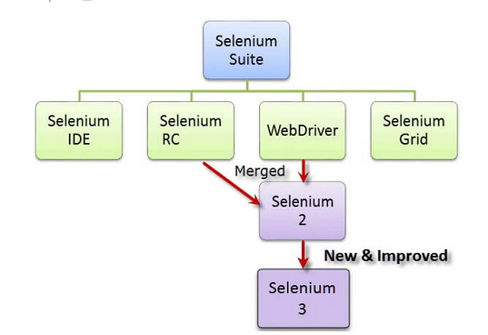

**How selenium webdriver works ?**

Every browser hasits internal support to automation, FF has plugins, IE has dll, chrome has a chrome driver to support automation. Webdriver drives the browsers using these browser’s internal automation support.

It uses an analogy with taxi driving.

[Selenium WebDriver drives a browser the same way a taxi driver drives a cab](http://test-able.blogspot.com/2016/01/webdriver-test-automation-like-taxi-driving.html).

In taxi driving, there are typically 3 actors:

* **the client;**he tells the taxi driver where he wants to go and how to get there
* **the taxi driver;** he executes the client's requests; the taxi driver sends his own requests to the car
* **the car;**the car executes the taxi driver's requests

The client gets to the destination through dialogues that happen between the

In test automation with Selenium WebDriver (and other tools), there are 3 actors as well:

* **test engineer that writes the automation code**; the automation code sends requests to the browser driver component
* **the browser driver component**; it executes the test engineer requests; it sends its own request to the browser
* **the browser**; it executes the browser driver requests